Layout

[Home By Experience](https://www.byexperience.co.uk/)

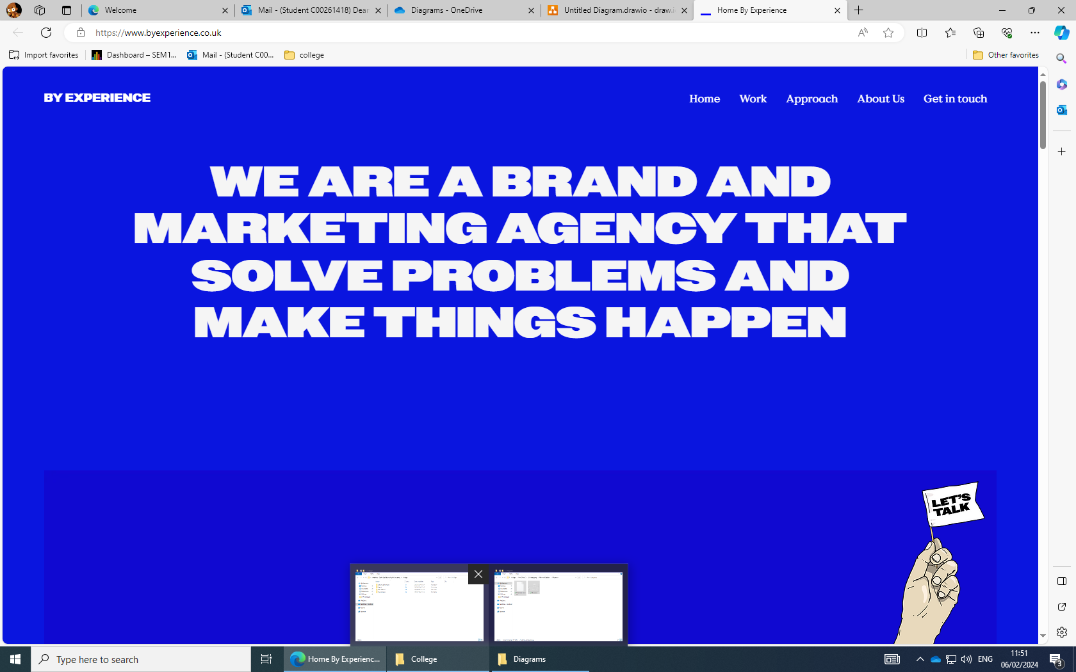

I like the Dark blue and think it would make for a good colour choice for my portfolio website

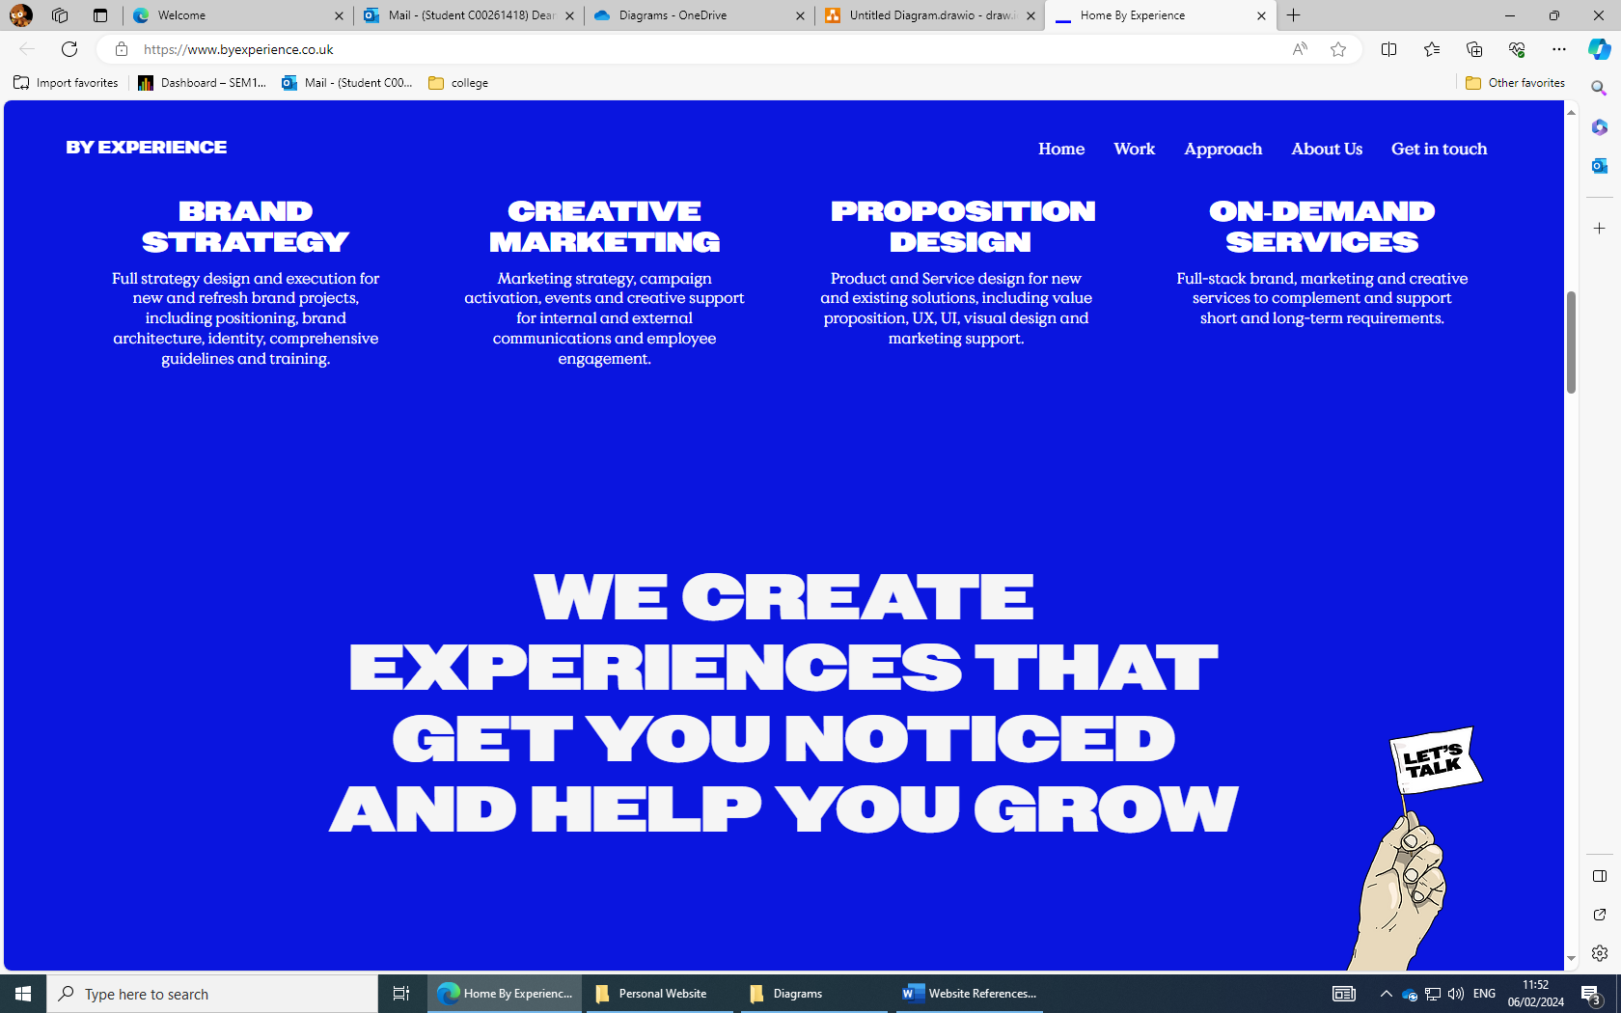

I also like the scrollable Ui that can be found on this website.

[HOME | analeovy](https://www.analeovy.com/)

[Brisbane Professional Photographer | Alingwenphotography | Brisbane](https://www.alingwenphotography.com/)

[Wendy Ju (wenxinwendyju.com)](https://www.wenxinwendyju.com/)

Navigation

[We help build meaningful brands through design. (stevewolf.co)](https://www.stevewolf.co/)